**CMSC 203 Assignment 6**

**Pseudocode (Function1.java)**

1. Function1 extends Function
2. answerString method takes 4 double parameters (x, y, z, optVal).
   * return x, y, optVal as string.
3. fnValue method takes a double parameter x.
   * if x is less than or equal to 0, return the max value
   * Else, return (x / 8) + ((sqrt(4+(6 – x) ^ 2)) / 3)
4. getXVal method takes a double parameter x
   * return x
5. getYVal method takes a double parameter x
   * return sqrt(4+(6-x)^2)
6. getZVal method takes a double parameter x
   * return 0
7. toString method
   * Return "Minimize the time it takes to reach the island by running and swimming."

**Test Plan**

|  |  |  |  |  |
| --- | --- | --- | --- | --- |
| # | Input | Expected Output | Actual Output | Remarks |
| 1 | Left extent: 0  Right extent: 20 | Run Distance: 5.20 mi  Swim Distance: 2. 15 mi  Time: 1.37 hours | Run Distance: 5.20 mi  Swim Distance: 2. 15 mi  Time: 1.37 hours | Yes |
| 2 | Left Extent: 0  Right Extent: 15 | Run Distance: 5.17 mi  Swim Distance: 2. 16 mi  Time: 1.37 hours | Run Distance: 5.17 mi  Swim Distance: 2. 16 mi  Time: 1.37 hours | Yes |

**Test Case 1 Screenshot**

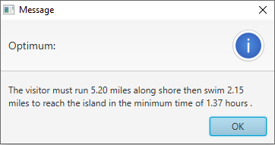

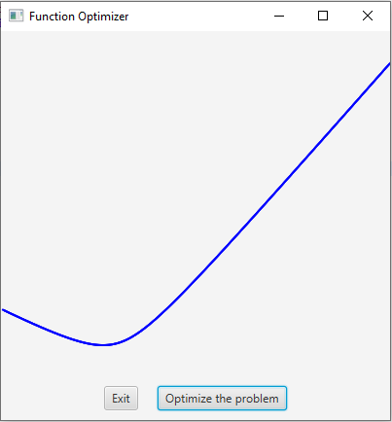

**Learning Experience**

This assignment was easy and straight forward. This assignment was based on a previous lab problem, so it was very straight forward. Combining concepts from my math class helped me understand both the mathematical and java concepts better. The videos provided for the assignment helped me to understand the mathematical side of the assignment and doing the assignment clarified the concepts of inheritance and polymorphism. Optimization is important in real life to work efficiently. I can find out optimum results for real life problems after doing this assignment.